Database Description

The Workshop Management System is designed to streamline the organization, promotion, and execution of computer science workshops, as well as associated tests and evaluations. The system includes functionality for handling workshop and test registrations, session and test management, payments, and participant engagement. It supports three primary user roles: Admin, Instructor, and Participant, each with specific permissions and access to relevant features within the platform.
- Admin: Responsible for managing users and overseeing the entire system. Admins monitor workshops, tests, participant registrations, and payments to ensure smooth operations and adherence to platform guidelines.
- Instructor: Instructors manage workshop sessions and tests. They create, organize, and assign sessions to specific workshops, track participant engagement, and may also oversee evaluations.
- Participant: Participants can browse and register for available workshops and tests. They have access to workshop materials, attend sessions, and participate in evaluations.

Workshop Management
Instructors can create and manage workshops, including scheduling sessions, setting capacity limits, and determining pricing (workshops can be either free or paid). Each workshop consists of multiple sessions, with details such as title, date, time, and assigned instructor.

Sessions
Each workshop may contain multiple sessions. Sessions can be customized with details like title, date, time, and category. Instructors are responsible for managing these sessions, ensuring they align with the overall workshop objectives.

Test Management
In addition to workshops, the system supports tests to assess participant knowledge. Tests include attributes like title, description, date, time, venue, capacity, and customizable questions. Participants register for tests separately, and instructors can track test participation and results.

Registration
Participants register for both workshops and tests, with the system tracking all registration details. Registrations ensure that participants are enrolled in the appropriate sessions or tests and can access related materials.

Payments
For paid workshops, secure payment processing is integrated, supporting multiple payment methods, including credit card, debit card, and cash. The system tracks all participant payments, and includes features for invoice generation and refunds when needed.

Table Name | Description | Attributes
Admin | Stores admin user information and credentials for overseeing the system. | id, firstName, lastName, phoneNo, dob, street, city, state, zip, gender, email, password, createdAt, updatedAt
Participant | Contains participant details, allowing users to register and engage with workshops and tests. | id, firstName, lastName, email, password, phoneNo, dob, street, city, state, zip, gender, createdAt, updatedAt
Instructor | Holds information about instructors who manage sessions and conduct workshops. | id, firstName, lastName, email, password, phoneNo, dob, street, city, state, zip, gender, createdAt, updatedAt
Workshop | Defines workshops with scheduling, capacity, and pricing details, which may consist of sessions. | id, title, description, venue, startDate, endDate, capacity, price, workshopType, createdAt, updatedAt
Session | Represents individual sessions within a workshop, specifying the date, time, and assigned instructor. | id, title, date, startTime, endTime, category, workshopId, instructorId, createdAt, updatedAt
Registration | Tracks participant registrations for workshops and sessions, connecting them with payment details. | id, participantId, sessionId, paymentId, createdAt, updatedAt
Payment | Records participant payments for workshops, including the amount and method used. | id, amount, method, participantId, reservationId, createdAt, updatedAt
Test | Defines tests for participant evaluations, with details like venue, date, and included questions. | id, title, description, date, startTime, endTime, venue, capacity, questions, createdAt, updatedAt
TestRegistration | Logs participant registrations for tests, connecting them to specific tests for tracking purposes. | id, participantId, testId, createdAt, updatedAt
|
ER Diagram

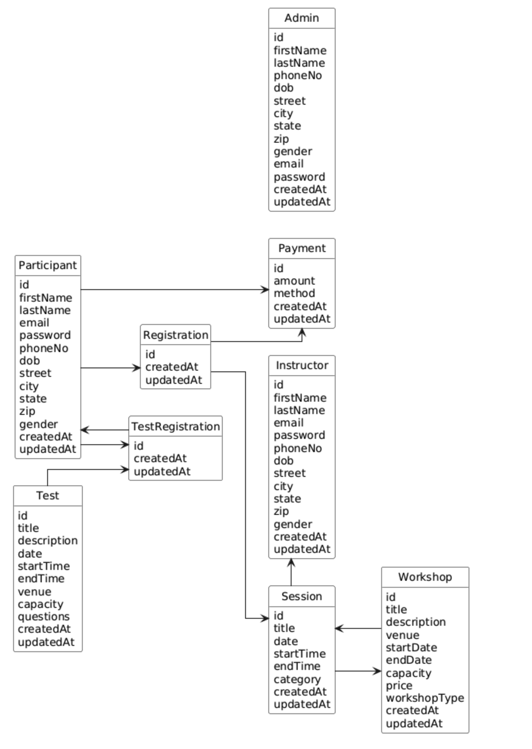
Sample Data

{
"Admin": [
{
"id": "admin1",
"firstName": "Alice",
"lastName": "Johnson",
"phoneNo": "+1234567890",
"dob": "1985-05-15T00:00:00Z",
"street": "123 Admin St",
"city": "Admin City",
"state": "Admin State",
"zip": "12345",
"gender": "FEMALE",
"email": "alice.johnson@example.com",
"password": "hashedpassword123",
"createdAt": "2023-01-01T10:00:00Z",
"updatedAt": "2023-01-01T10:00:00Z"
}
],
"Participant": [
{
"id": "participant1",
"firstName": "Bob",
"lastName": "Smith",
"email": "bob.smith@example.com",
"password": "hashedpassword456",
"phoneNo": "+0987654321",
"dob": "1990-08-20T00:00:00Z",
"street": "456 Participant Ln",
"city": "Participant City",
"state": "Participant State",
"zip": "67890",
"gender": "MALE",
"createdAt": "2023-01-02T12:00:00Z",
"updatedAt": "2023-01-02T12:00:00Z"
}
],
"Instructor": [
{
"id": "instructor1",
"firstName": "Clara",
"lastName": "Brown",
"email": "clara.brown@example.com",
"password": "hashedpassword789",
"phoneNo": "+1122334455",
"dob": "1988-03-10T00:00:00Z",
"street": "789 Instructor Blvd",
"city": "Instructor City",
"state": "Instructor State",
"zip": "54321",
"gender": "FEMALE",
"createdAt": "2023-01-03T15:00:00Z",
"updatedAt": "2023-01-03T15:00:00Z"
}
],
"Workshop": [
{
"id": "workshop1",
"title": "Introduction to AI",
"description": "A beginner-friendly workshop on AI fundamentals.",
"venue": "Main Hall, Tech Center",
"startDate": "2023-04-01T09:00:00Z",
"endDate": "2023-04-03T17:00:00Z",
"capacity": 30,
"price": 100.0,
"workshopType": "PAID",
"createdAt": "2023-02-01T10:00:00Z",
"updatedAt": "2023-02-01T10:00:00Z"
}
],
"Session": [
{
"id": "session1",
"title": "AI Basics",
"date": "2023-04-01T09:00:00Z",
"startTime": "2023-04-01T09:00:00Z",
"endTime": "2023-04-01T12:00:00Z",
"category": "Introduction",
"workshopId": "workshop1",
"instructorId": "instructor1",
"createdAt": "2023-02-15T10:00:00Z",
"updatedAt": "2023-02-15T10:00:00Z"
}
],
"Registration": [
{
"id": "registration1",
"participantId": "participant1",
"sessionId": "session1",
"createdAt": "2023-03-01T10:00:00Z",
"updatedAt": "2023-03-01T10:00:00Z"
}
],
"Payment": [
{
"id": "payment1",
"amount": 100.0,
"method": "CREDIT_CARD",
"participantId": "participant1",
"reservationId": "registration1",
"createdAt": "2023-03-02T10:00:00Z",
"updatedAt": "2023-03-02T10:00:00Z"
}
],
"Test": [
{
"id": "test1",
"title": "AI Proficiency Test",
"description": "A test to evaluate AI knowledge.",
"date": "2023-04-05T10:00:00Z",
"startTime": "2023-04-05T10:00:00Z",
"endTime": "2023-04-05T12:00:00Z",
"venue": "Room 101, Tech Center",
"capacity": 25,
"questions": ["What is AI?", "Describe supervised learning."],
"createdAt": "2023-02-20T10:00:00Z",
"updatedAt": "2023-02-20T10:00:00Z"
}
],
"TestRegistration": [
{
"id": "testRegistration1",
"participantId": "participant1",
"testId": "test1",
"createdAt": "2023-03-10T10:00:00Z",
"updatedAt": "2023-03-10T10:00:00Z"
}
]
}

